Adele Drew Scholarship Application

ABOUT THE SCHOLARSHIP
One $250 scholarship goes to a member of the Southern Methodist University chapter and another $250 scholarship is given to a member of another Texas collegiate chapter on a rotating basis. The recipient can use the money to her discretion. For 2019-2020 school year, a member from the Baylor University collegiate chapter will receive the scholarship. Please submit no later than Monday, November 4, 2019.

iNFORMATION nEEDED
Applicant Name: ____________________________________________________________________________
Email: __________________________________ Phone Number: __________________________________

Current Address: ___________________________________________________________________________
City, State, Zip: _____________________________________________________________________________

Permanent Address:_________________________________________________________________________
City, State, Zip: _______________________________________________________________________________

Major:________________________________________________________ GPA:___________________________
SUBMISSION NEEDS: Please submit no later than Monday, November 4, 2019.
- An updated resume that includes all school activities and all leadership positions held, as well as honors and rewards you have received.
- A one page description of what being a sister in Alpha Chi Omega means to you.

E-mail applications to Meredith Walski at fraternityrelations@betakappabeta.com

Recipients will be notified by Monday, December 9, 2019 if they were selected for the award.

Thank you to all of our sisters who apply!

ADELE FIEVE DREW

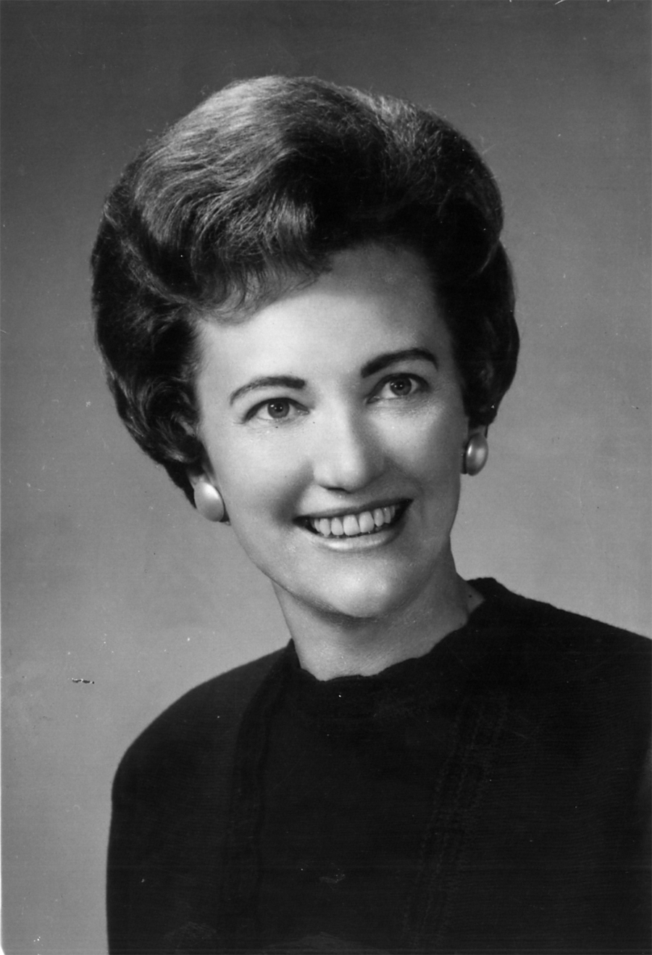
Adele Fieve Drew, a 1939 initiate of the Alpha Lambda chapter, was National President of Alpha Chi Omega from August 1970 until August 1976—one of Alpha Chi Omega’s longest serving Presidents. In her honor and with her donations, the Beta Kappa Beta alumnae chapter created the Adele Drew Scholarship fund.

Her leadership roles in Alpha Chi Omega spanned 34 consecutive years. Not only was she a National President but also Province President, District Alumnae Chairman, National Chairman of Fraternity Education, National Chairman of Social Development, Convention Manager, and National Alumnae Vice President.

Alpha Chi Omega was a family affair for the Drews. For the 34 years, when Adele held leadership positions, she made sure that all family vacations were planned around Alpha Chi’s national meetings. Adele’s love of her family and their support for Alpha Chi Omega were evident.

The Alpha Chi Omega symphony held a special place in Adele’s heart, especially the line “To see beauty even in the common things of life”. Adele appreciated nature and enjoyed watching birds from her kitchen table as well as feeding them, and watching flowers bloom.

Adele wrote an article for The Lyre summer issue 1976 titled “Looking Back Six Years.” Her words still stand strong and meaningful today. Here is an excerpt from that article.

“Yours, then, is a growing, constantly updating, vital Fraternity. Its growth has steadily continued in spite of depression, recession and four wars. The need for this kind of life-long association has been amply demonstrated as we continue. We have been given much and we have much to give. You are the future of the Fraternity.”

Adele Fieve Drew was a wonderful leader, role model, and sister. Her legacy lives on through this scholarship and through our past winners.
We wish you the best in the future through all you achieve.

Loyally,

Beta Kappa Beta
Adele Drew Scholarship Committee

